

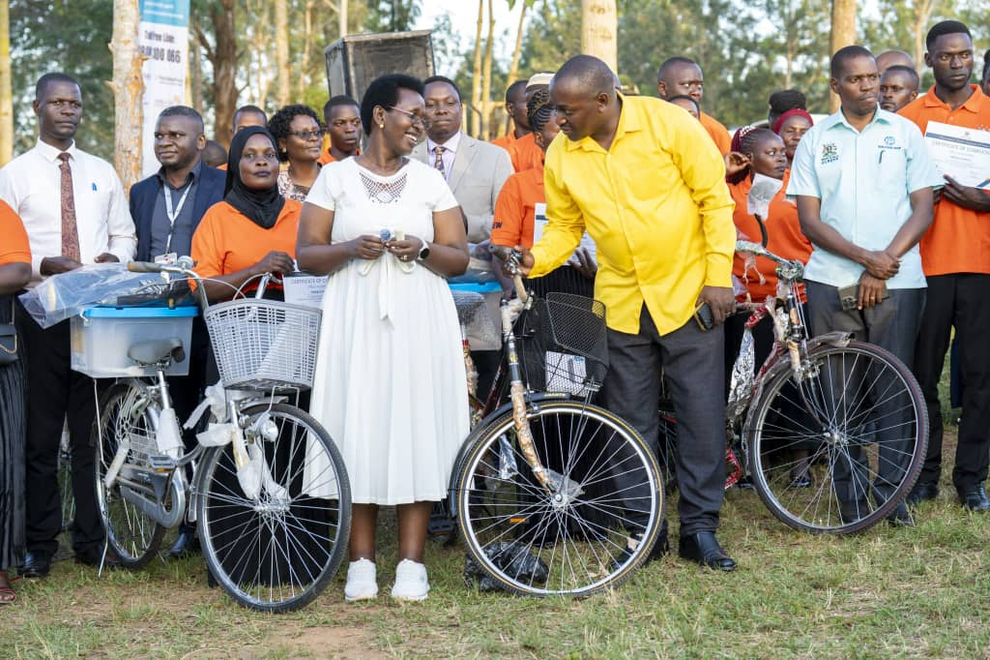
STATE OF LWENGO DISTRICT AFFAIRS ADDRESS

FINANCIAL YEAR
2024/2025

Presented by
Hon CPA Kitatta Ibrahim Al Malik
District Chairperson

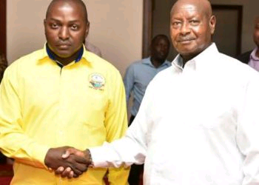

Mr. Speaker,
The Hon. Deputy Speaker
Resident District Commissioner,
Hon. Vice Chairperson
Members of the District Executive Committee,
Hon. District Councilors
Hon Members of Parliament,
The Chief Administrative Officer,
Members of Boards and Commissions,
Religious Leaders
Sub County Chairpersons
Development Partners
Heads of Departments and Sections
Distinguished Guests,
Ladies & Gentlemen

In fulfillment of Statutory requirements under the Local Government Act Cap 138, Sub
Section 13(5) it is with great pleasure that I here stand to deliver the my 4th State of the District Affairs Address to the District Council for the financial year ending 30th June 2025

It’s our vision as leaders of Lwengo District to “Achieve higher household income, full monetization and employment for sustainable socio-economic transformation in Lwengo district” This vision is in line with the Goal of the fourth National Development Plan 2025/2026- 2029/2030 (as Revised) which aims at increasing household incomes and improving the quality of life.
To achieve the above vision, the District has been and will continue to pursue a number of development strategies including:
- Maintaining peace and good governance.
- Commercialization of agriculture
- Reduce the cost of doing business
- Harnessing tourism potential
- Strengthening the private sector investment
- Fighting Corruption in all its forms
- Mindset change to promote focus on development
- Increasing Local Revenue Mobilization and collection without hurting businesses.
- Fight Extreme Poverty and Hunger
- Promotion of social services.
- Ensure that, children will be able to complete a full course of primary schooling.
- Reduce Child Mortality
- Fighting unemployment
- Foster infrastructural development at all levels
- Enhance provision of quality education at all levels
- Ensure environmental sustainability
- Promote Gender Equality and Empowerment of women, youth & PWDS.
- Promote Political and economic resilience
As you all know that our District has grown leaps and bounds since July 2010 when it was curved off Masaka, Lwengo is now 15 years.
My government has been stewarding Lwengo District for now 4 years of steady Transformative Development and growth.
Mr. Speaker Sir, allow me to bring to your attention some of the key events that have unfolded in the District since we took office four years ago.
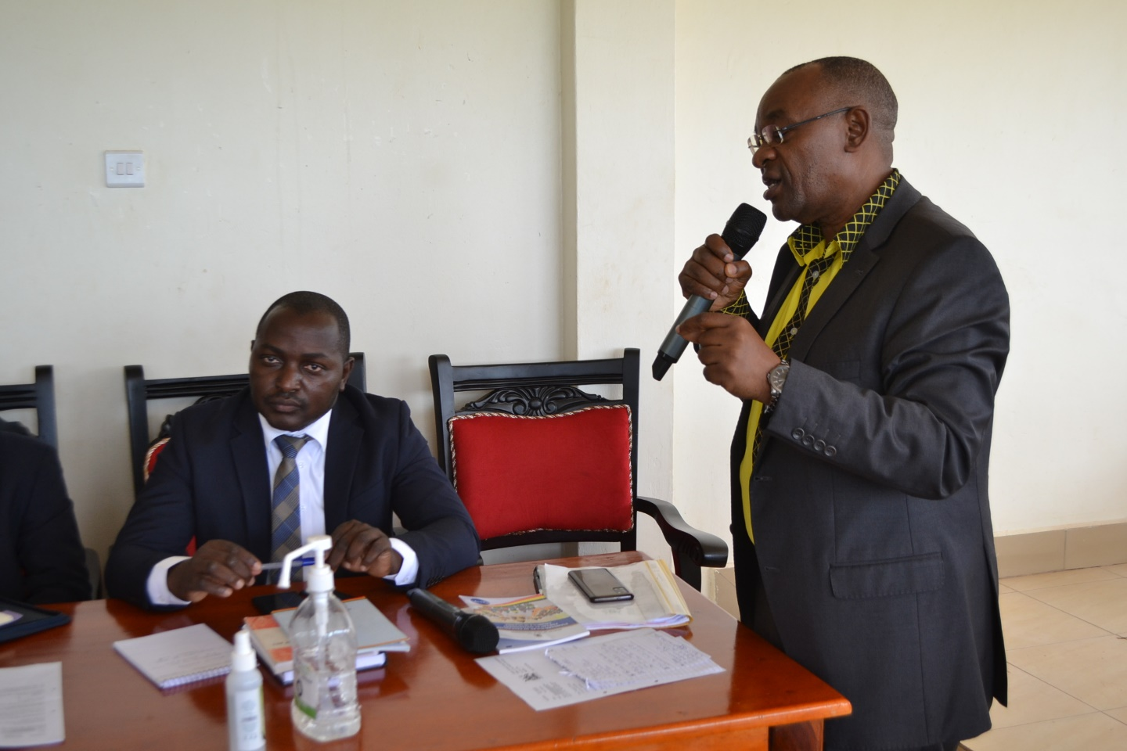

In the past years, The Population has tremendously grown from 297,200 People to 325,263 people according to the 2024 National Housing & Population Census (NPHC) second only to Rakai in the Greater Masaka Region.

Major Achievements of Governor CPA, Kittata Ibrahim Al Malik
- Grown the Lwengo District Budget from UGX 30,811,1999,000 in FY2020/2021 to UGX 42,343,421,0000 in FY2024/2025(In that period Local Revenue has more than tripled)
- Lwengo has been able to have a home of its own (Lwengo District Administration block) started by my predecessor and completed by my Government.
- Lwengo has two Seed Schools(Mbirizi and Katovu) constructed and equipped during my reign from zero to full operation with a Total Enrollment of over 4,000 students majority being own from the Lwengo Community.
- Upgraded and equipped 2 Health Center IIs to HCIIIs greatly improving the Health Sector under the Human Capital Development of the NDPIV now serving over 10,000 from a mere 4,000.
- Under the Transport Programme more than 5Kms of Tarmac has been added onto the Road Network under my Watch with Town Council equipped with Solar Street Lights. In addition over 447KM of Roads has been maintained.
- Under Community Mobilization and Mind set change; Community Based Services, 60 women groups of 673 beneficiaries were supported with UWEP funds totaling to 432,012,275. 125 youth groups have been supported with YLP funds totaling to 894,277,450 and 62 PWD Groups have benefited from special grant with a total of Shs 60 million. 15 groups have benefited under the PCA model with Shs. 450,000,000. 3,500 vulnerable persons accessed free legal services. A Family Desk has been set up by FIDA Uganda at Mbirizi Magistrate’s Court.
- It is under my reign when Boards and Commissions have been overhauled; the Lwengo District Service Commission has been overhauled and greatly increased the Proportion of Lwengo residents being recruited into to service, the Land Board has also greatly improved significantly reducing Land Conflicts an extent of ensuring that Lwengo District benefits from its Land through ensuring that Ground Rent is realized.
- In the Agro-Industrialization Programme; The Production and marketing services have been provided to the local community through agricultural extension services by increased number of field extension workers from 57% to 85%.
- Under the PDM flagship Programme Lwengo has been singled out as one of the Best Performing Districts with all the 45 Parishes being covered and all the SACCOs receiving more than 100Million.

PROGRAMME/ SECTOR PERFORMANCES FOR FINANCIAL YEAR 2024/2025 – AND PRIORITIES FOR FY 2025/2026.
Mr. Speaker Sir, allow me to bring to your attention issues that have been brought to our charge and handled in the FY2024/2025;
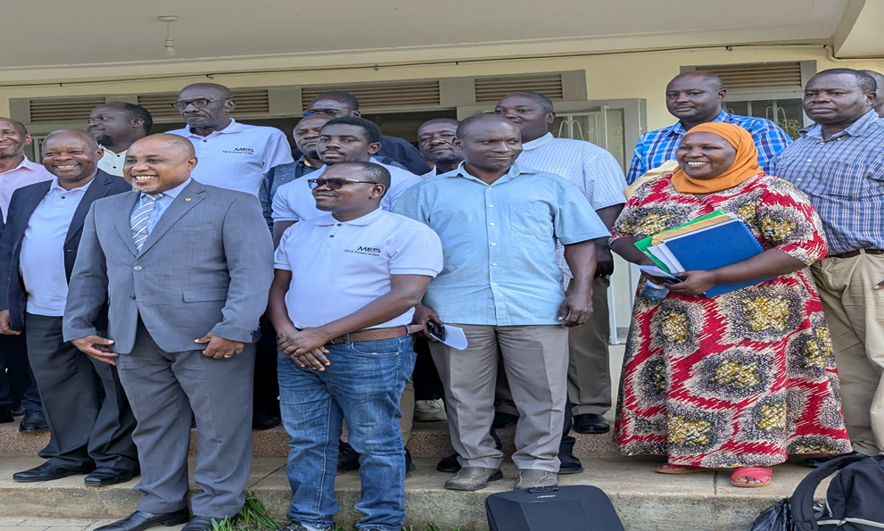
GOVERNANCE AND SECURITY PROGRAMME

ADMINISTRATION

The following milestones were achieved in the FY 2024/2025
Monitored and supervised departments, sub-counties and Town Councils in implementation of Government programs and projects, Disseminated government policies and public information on government projects and programs of Parish Development Model, UGIFT, among others, recruited new staff, placement and disciplinary actions. Undertook payroll management and control to ensure timely payment of salaries, pension, gratuity and emoluments
PROJECTS UNDER ADMINISTRATION DEPARTMENT FOR FY 2024/2025.
- Construction of market stall at Lwengo and abattoir at Kinoni TC
- Construction of market stall at Katovu TC
- Construction of 3no- 5 stance lined pit latrine at Mbirizi zone in Lwengo TC, Mweru zone and Kalule garage in Kyazanga TC
- Construction of Kyazanga Town Council Administration

In FY 2025/26, the Department has Planned the Following:
Conduct continuous trainings and mentoring of staff to improve efficiency and effectiveness in service delivery, monitoring staff performance to ensure timely delivery of key outputs and adherence to Government regulations and guidelines.
Monitor government programs and projects, payment of all utilities at the District and maintain security at the District. Carryout routine maintenance of the District website, provide high-speed internet services and disseminate public information to ensure good governance and accountability of public funds. The Department will ensure timely payment of staff salaries, pension and gratuity to gain confidence from staff, which improves staffs' well-being.

STATUTORY DEPARTMENT (COUNCIL, BOARDS AND COMMISSIONS)
The 5th Council has registered the following achievements
Held council meetings, Standing Committees, District Executive Committees and Business Committee sittings. Paid sitting allowance and ex-gratia for District Councilors for the last four years, and also paid for fuel for the District Executive Committee members, Speaker and Deputy Speaker. The District Budget for FY2025/2026 has also been passed.
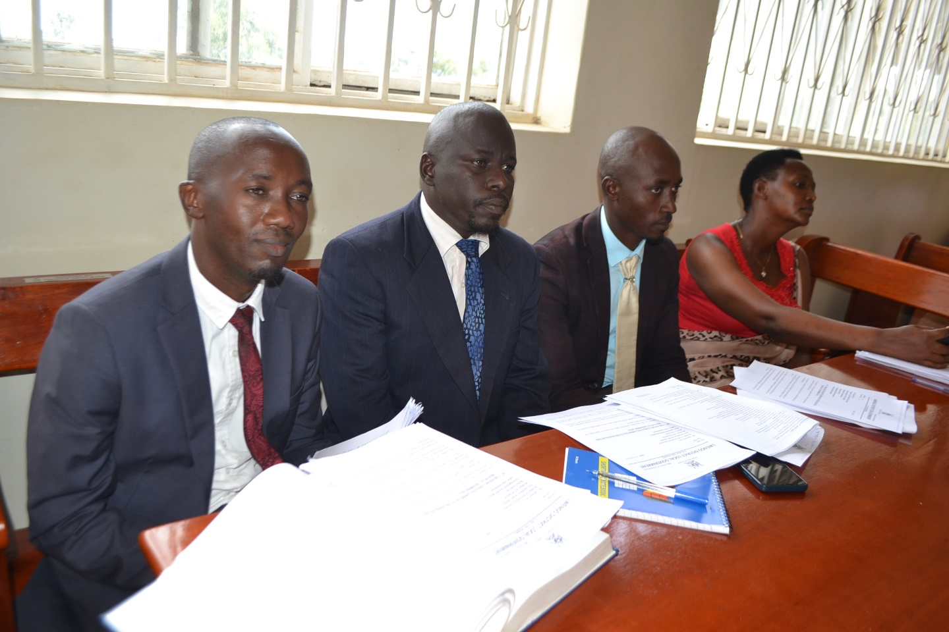

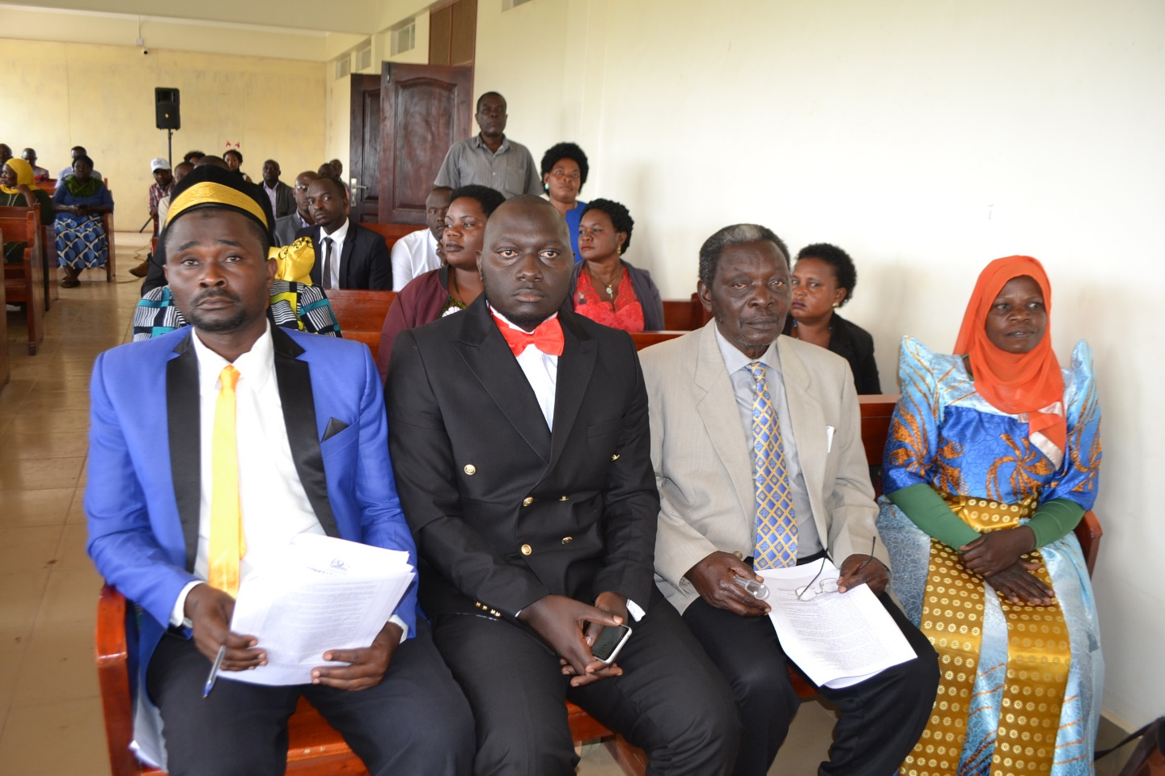

- District Service Commission

The commission achieved the Following; No. of meetings held 08, No. of Job adverts ran 02, No. of appointments on probation 165, No. of appointments on promotion 58, No. of appointment on transfer of service 17, No of appointments on the transfer with in service 01, No. of cases of appointments on redesignation 01, No. of appointments on renewal of local contracts 01, No. of staff confirmed into appointments 77, No. of staff granted study leave with pay 04, No. of cases of staff resignation from service 02, No. of staff retired on medical grounds 02, Noting general retirement of staff from the District Public Service 21, No. of cases of staff on leave without pay 02, No. of appointments on attainment of higher qualifications 11, No. of corrigenda 03, No. of staff retired in public interest 03, No. of staff terminated on abandonment of duty 43, No. of staff appointed with waiver to serving probation period 04, No. of cases on regularization of appointment 02 leading to a Total of 427

Contracts Committee/Procurement and Disposal Unit.

In the FY2025/2026 Department Plans the following;
To continue to Organize and conduct District Executive Committees, Sectoral Committees and Council meetings. Pay staff salaries, facilitate councilors with fuel and allowances for monitoring activities, prepare and submit PBS reports, work plans and budgets.

The District Service Commission, to continue to handle appointments in the DSC, confirm staffs into their appointments, disciplinary control over staff, approve long term trainings of District staff and handle any submissions that might be presented to it.

Under the District Land Board, the Department will organize and convene land board meetings to handle land issues and conduct field visits to resolve land disputes.

The Local Government Public Accounts Committee will organize and convene LGPAC meetings to review Internal, External Audit reports and any other special audit reports that will arise and make recommendations to the Chief Administrative Officer and District Council for implementation.

Development Plan Implementation
INTERNAL AUDIT DEPARTMENT
The department performed the following activities;

Conducted audits for FY 2021/22, 2022/23, 2023/24 and 1st, 2nd and 3rd quarter for FY 2024/2025 for district departments, sub-counties, schools and Health facilities. Witnessed handing/taking over of DEO, PAS, Senior Assistant Secretaries, Town Clerks, Head teachers, Health In-charges, Planner Finance Officer and other staff.
Also carried out the verification report on actions taken by Accounting Officer on Internal Auditors report for FY 2021/2022, 2022/23 & 2023/24 and submitted it to Internal Auditor General Ministry of Finance, Planning & Economic Development.

In the FY2025/2026, this Department will implement the following;
Conduct audit for District Departments, 6 Sub-counties, 4 Town Councils, USE Schools, Health Centers and UPE Schools for 4th quarter FY 2024/2025. 1st, 2nd and 3rd quarter FY 2025/2026, Monitoring of projects implemented in the FY 2025/2026 such as Roads, Micro-Irrigation projects, water projects and carry out the verification reports on actions taken by Accounting Officer on Internal Auditor’s report and Auditor General reports.

FINANCE DEPARTMENT
The Key achievements were;
Held Departmental meetings to discuss and analyze performance, challenges and strategies to improve on service delivery, Made consultations with the Line Ministry over various issues especially on IFMS, e-cash and cash limits, Invoiced and remitted funds for Lower Local Governments, USE, UPE, Technical as well as Health Centers. The Department also inspected projects to ascertain value for money both at Lower Local Governments and District, Filed statutory returns for PAYE and WHT, Followed up on Accountabilities for staff and LLGs, Prepared and submitted Final Adjusted Annual financial statements for Financial Year 2023/2024 to Auditor General and Accountant General in accordance with the financial requirements. Also monitored and supervised LLGs on revenue mobilization, Prepared and presented the revenue enhancement plan, work plans and budget for FY 2025/26 to committees for discussion and approval. Coordinated the External and Internal audits by providing all required information to the Auditors and Responded to queries raised by both Internal and External audit from FY 2021/2022 to the current year.
In the Financial Year 2025/2026, the Department will;
Strengthen and coordinate with development partners to ensure that their off-budget interventions are aligned to priorities in the five year development plan, strengthen the electronic revenue data base to ensure that all revenue sources are tracked and monitored at all Lower Local Governments and also improve the Master Data at the District. Comply with the existing laws and regulation relating to resource mobilization to improve Revenue performance and attract donor attention.
Under Budgeting, the Sector will work with the Planning Department in aligning IPFs with the planned activities linked to NDP IV to ensure that we have a balanced budget. Conduct a mass awareness campaign through radio talk shows to mobilize the public and explain key priorities of the District in the District Development Plan, Budget Framework Paper, annual budgets and work plans.
PLANNING DEPARTMENT
The Department performed the following activities;
Coordinated the Preparation, compiled and submitted the PBS District Quarterly Performance Reports for FY2024/2025 for Quarter 1, 2 and 3. Organized the District Budget Conference for FY2025/2026, Coordinated and submitted the District Budget for FY2025/2026 and also Supervised the Uganda Aquaculture Census 2024/2025. The department also coordinated the Internal LGPA (Mock Assessment) for 2024, backstopped Assessments on the Implementation of DDEG in all LLGs and conducted 9 monthly District Technical Planning Committee meetings. The Department also mobilized and engaged Lower Local Governments in Data collection for preparation of BFP, work plans and Budget estimates for FY 2025/2026.

In the Financial Year 2025/2026, the Department will;
Hold one participatory planning meeting in each of the Lower Local Governments, coordinate 12 District Technical Planning Committee meetings with all Heads of Departments and Heads of Sectors, Prepare and submit quarterly and Annual PBS based Work plans and reports to Ministry of Finance, Planning and Economic Development, line Ministries and other stakeholders, Submit the DDP IV, and also monitor its implementation. Monitor the implementation of the 5-year strategic plan for statistics and government programs, Acquire appropriate Spatial Planning Equipment like GPS machines and related work station equipment, Coordinate Internal Local Government Performance Assessment at sector and LLG levels and District Budget Conference for FY 2026/2027. Conduct annual performance review meeting at the District level, Supervise all Sectors and LLG AWPB to ensure they are aligned to the Five Year DDP IV and LLG DPs, Finalize and Operationalize the District M&E framework and train stakeholders in M&E tools, data collection, new DDEG guidelines 2025, update the District Statistical Abstract for FY 2025 and also procure a new laptop for the planner.

AGRO-INDUSTRIALISATION PROGRAMME
PRODUCTION AND MARKETING DEPARTMENT
Achievements for Production Department FY 2024/25
The department concentrated more on Training 33 PDM SACCO Boards to use WENDI mobile wallet, 102 PDM tablets were given to local leaders’ i.e 45 to Board Chairpersons, 45 to Parish Chiefs, 10 to Community Development officers and 2 to planner and SITO, 45 PDM demonstrations established at Parish level to Parish Model Beneficiaries: 15 were piggery, 5 poultry, 20 coffee and 5 banana production. Post bank trained Community on WENDI operations together with Housing Finance. 4 Project monitoring carried out by all Council members to ugift plants established. 43,204 routine Extension activities were carried out by field staff. Among the major activities carried out was FMD vaccinations to all susceptible animals against FMDs with the assistance of Vaccines received from Ministry of Agriculture, Animal Industry and Fisheries (MAAIF).

The Line ministry also extended a cold Chain for maintaining FMD Vaccines in good order which resulted in the lifting of FMD quarantine recently.
2 new staff were recruited in crop section and one promoted to senior staff and one staff crossed to crop section. In other wards all LLGs have atleast two staff ie a crop and veterinary staff.

The ministry extended to us the new Laptop for Ugift project for tracking progress using established App from the Ministry.

All capital development funds were utilized as planned to Nil.

S/N | Cumulative report from production | Remarks
1 | UGiFT Micro scale Irrigation program  - All the 10 contracts that were signed to support 10 beneficiary farmers with equipment supplied under micro scale irrigation program are already working on ground. Also the 4 which were incomplete by close of FY2023/2024 were completed, totaling to 14 sites completed this financial year.  Funds utilized was used and a balance of 26 million still pending as retention to suppliers that will be catered for from raised Co –funding from farmer beneficiaries as guided by MAAIF to CAOs  - Inspected and monitored 34 irrigation equipment beneficiaries and are all operational.  Entomology sector  - 16 Supervisory visits held in 10 LLGs were held – work in field is promising especially coffee farmers continuously integrate bee keeping on ground.  - 4 Sector planning meetings held where achievements and challenges are shared and work plans made.  - Farmers’ training in Kakoma mode village and supervision of inputs from state house done. Also other Government projects are monitored.  - Worked on bats infestations and monkey invasion. UWA has been so supportive to Hippos reduction and community compassions: ref is Kyoko – Kagganda in Kingo sub county. Area Vet staff was so supportive in mobilization of the community.  The biggest challenge realized was lack of PPE that hinders the Vermin control activities. Also lack of protective gears and smokers still discomforts practicing farmers during harvesting of honey.  Recommendation; Continued lobbying for those mentioned above.  Crop sector  - Backstopping extension staff in their respective sub-counties. This included visiting Kyazanga, Kisseka, Ndagwe, Kkingo and Lwengo sub county  - Monitoring and supervision of PDM sector activities and guidance where need be. These included among others: The PAD activities in Kakoma- Kyazanga where the beneficiaries were trained and supported on different technologies in crop agronomy which include spacing, soil and water conservation, coffee pruning, fertilizer application and quality assurance. 80% work seen is promising.  - Participated in the establishment of beans demo with ASAP organization at Kyazanga integrity cooperative society.  - Monitored the functionality of farmer schools in Lwengo town council, Ndagwe, Kisseka and Lwengo sub county  - Monitored the activities of Makondo and Kyazanga cooperatives  - supervised the functionality of micro scale irrigation facility at Kyamaganda for the Masaka diocese  - Visited several Coffee Nurseries e.g Mutindo coffee nursery operators for bench marking on coffee nursery management.  - Held a multi stakeholder meeting of coffee value chain actors at the district which was attended by nursery operators, coffee traders, local leaders and technical staff.  - Four Sector Coordination meetings held. We thank Hon. Kampiire Mary -Secretary for production and deputy CAO Mr. Nyende Alex who always attended and guided production staffs in the meetings.  - Attended several coffee platforms on agronomic practices and quality assurance organized by Lwengo district united farmers SACCO.  - Different Staffs attended different Agricultural shows organized at different levels both regional and National levels were staff capacities were enriched through knowledge sharing.  Veterinary section  - 4 meetings for LC 1, 111, farmers and some councilors on mobilization for vaccination of animals against FMD in Lwengo TC, Kkingo and Kisekka Sub counties.  - Guided veterinary staff on collection of data using new format and submitted to MAAIF.  - Inspection of animals and animal products which resulted in lifting of the FMD quarantine in Lwengo District.  - Vaccination of animals against FMD is ongoing (18,786 cattle,15797 goats,2919sheep and 370 pigs as at 19th March 2025.  - Backstopping of staff at sub-counties.  - Routine animal diseases investigation and surveillance was done in all sub counties mainly for Tick borne diseases, African swine fever, black quarter, lumpy skin, PPR, new castle disease and Foot and mouth disease.  Challenge – un lawful animal sale in the District as we are under Quarantine; however, efforts through massive vaccination to activate Lifting of the quarantine by MAAIF is on course.  Fisheries Sector  - 10 farmers were mobilized to receive funds from FOODLAND project. So far 10 farmers from Kkingo, Lwengo and Kyazanga sub counties have received 10 million in total from that project.  - 10 trainings to farmers on profitability of fish farming and how to start up fish farming.  - 6 sensitizations on fisheries rules and regulations were carried out  - 30 Fish farmers were trained on making feeds using local ingredients, water quality management.  - Monitoring of 6 farmers who received fingerlings from NAADS

The Government extended 4,500,000,000/ (four billion five hundred million to 45 PDM SACCOs each one hundred million based at Parish level. It also extended 45 million to facilitate 45 PDCs at Parish level. It also facilitated 45 SACCO boards with 22,500,000/ for the work extended to PDM beneficiaries and 45Parish chiefs/ Town Agents with 54,000,000 as housing allowance.
Cumulatively the Government has sent 13,806,000,000/ shillings to 45 PDM SACCOs for beneficiaries to benefit in form of loan to households. Success stories show that women are progressing better than other categories.

CHALLENGES
- Some Co-funded money will be refunded to farmers due to limited funds received this year and the district could not reach all those who showed interests in water for production.
- Failure to use 5 VERMACO motorcycles donated to the district from OPM’s Office up to now. Efforts made but not yet yielded positively to acquire number plates from OPM’s Office.
- Vandalization and theft of irrigation equipment is on the rise.
- Prolonged dry spell affected Coffee production and lowered its quality and yields.

Recommendations
- Involvement of the security team to curb the raising theft of irrigation equipment.
- LLGs PDM focal persons to consolidate PDM performance reports for district core team review for smooth implementation by attaching a list of beneficiaries according to enterprises.
- Sensitization of farmers and other stakeholders on soil water conservation, irrigation technologies and linking farmers to irrigation equipment suppliers.
- Joint effort for enforcing quarantine restrictions on ground.

PDM Cumulative Status Report as of Forth Quarter FY 24/25

Major activity for the quarter was receiving 33 WENDI codes for 33 PDM SACCO registered to WENDI mobile wallet in Post Bank/ Housing Finance. By close of the quarter, all were successful.

CATEGORIES | AMOUNT SHARED CUMMULATIVELY
Number of Parishes | 45
Capitalization Per Parish | 306,800,000
Women 30% | 3,331,800,000
Youth 30% | 3,331,800,000
Elderly 10% | 1,110,600,000
PWDs 10% | 1,110,600,000
Others 20% | 2,221,200,000
Total number of Beneficiaries | 11,475
Grand Total | 13,806,000,000
Total Disbursement | 11,095,191,000
Overall Balance for 45 Parishes | 2,710,808,759
All 45 Parish Chiefs/ Town Agents received their housing allowance equivalent to 1,200,000/ each totaling to 54,000,000/ and Parish Development Committees each was facilitated with 1,000,000/ totaling to 45,000,000/ as guided and budgeted FY 2024/25 by PDM Secretariat. The SACCO boards each was facilitated with 500,000/ totaling to 22,500,000/.

Commissioning of micro scale irrigation
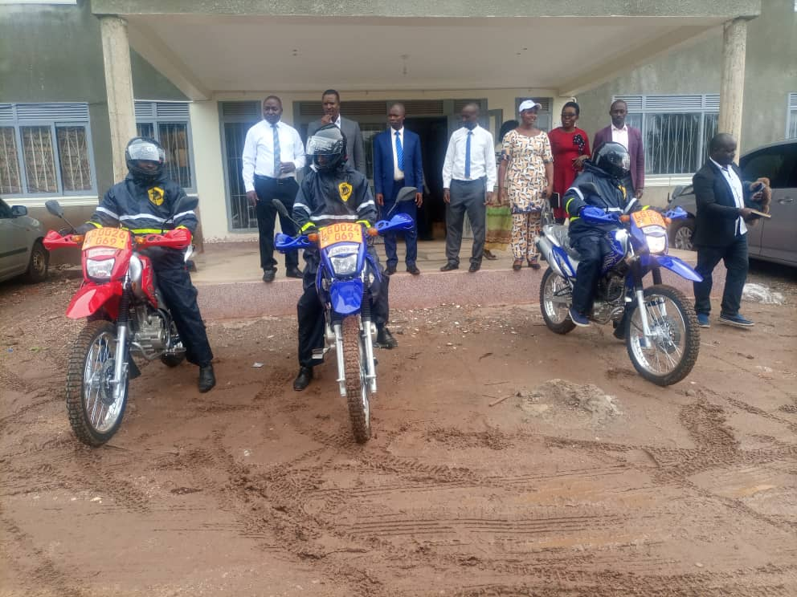
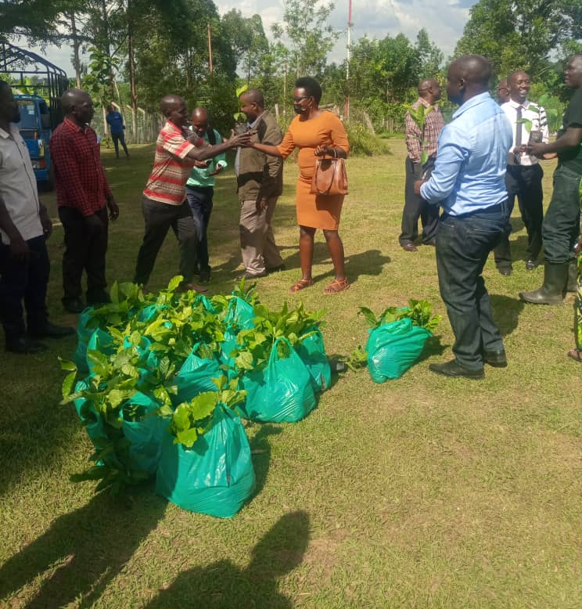

Distribution of Coffee seedlings from UCDA Distribution of motor cycles to extension staff

In the FY2025/2026, Production Department with all its sectors will;
Mr. Speaker Sir, the production department had planned the following activities; Establishment of a slaughter slab at Kyazanga Town Council and Procurement of a Motorcycle for a field officer.
Intensify control of pests/ parasites/ vermin and diseases of both crops and Livestock, Promote commercialized Agriculture through Parish Development Model and VAM, commercialization of agriculture and enforcement of quality assurance through inspection of crop nurseries, input dealer inspection, and other agro related inputs dealers, Give guidance and support to agro-processing (Bee farmers inclusive), control of pests like white flies through setting up of traps especially for fruit trees and for identification of tsetse flies and conduct continuous surveillance on crop and livestock diseases and pests in all sub counties, Procure Strichycline sulphate for destroying stray dogs and coordinate the vaccination of livestock on major diseases including local poultry and chicken, Establishment of management committees/ task forces for major crop and livestock diseases, Seasonal Collection of agricultural statistical data to guide, Promote and link farmers to research organizations for acquisition of most recent research developments, Identification and use of improved planting &breeding materials (AI, Clonal coffee, tissue culture banana, quick maturing Maize and bean varieties), Identification, mobilization, training and support to capable farmers for simple irrigation technologies/ schemes, Lobbying for heavy earth moving equipment for construction of water tanks and valley dams for livestock and simple irrigation, Promotion of water harvesting from roofs and run-off water for domestic use and production respectively, Empowering farmers with situational analysis demand articulation priority setting skills (participatory planning) that will guide farmers deal effectively with their immediate needs and hence appropriate demands in terms of services, technologies, information, and other relevant information, Identification and registration of agro-processing plants and promotion of more along the value chain, Establishment of market information system at lower local governments and the district, Mobilization and Organization of farmers into high level farmer organizations like producer and marketing groups and train them on group dynamics and leadership skills, Promotion of fish farming for farmers with water sources and those capable of harvesting water for fish farming, Promotion of use of high value inputs (fertilizers, pesticides, herbicides) for up scaling of enterprises of crop, livestock, fish and others, Identification and registration of farmer organizations and / or institutions and formation of farmer platforms along the value chain, so that they can benefit from service providers both public and private, Promotion of sustainable land management technologies like zero tillage, fertilizer use, soil testing, soil conservation structure establishment and Link farmers to research & other value chain actors; to increase farmer awareness on the existing improved technologies from research (NARO): - improved seed, artificial insemination, fertilizer, insecticides, soil & water conservation, climate smart agriculture; appropriate technical skills like post-harvest handling, value addition to mention a few.

HUMAN CAPITAL DEVELOPMENT

EDUCATION AND SPORTS DEPARTMENT
The Department has so far achieved the following during FY 2024/2025;
- Improved performance in the Primary Leaving Examinations
- Improved performance in the co-curricular activities. Merged the 3rd at primary schools’ National championship in Netball in Soroti. Lwengo was the Champion in Males at the region Tarehe Sita Marathon in Kyotera.
- Improved teacher attendance to duty.
- Improved working relationship with relevant stakeholders.
- Digitalized school inspection.
- Improved enrolment of learners on Education Management Information System.

- Projects in Primary Schools:
S/n | Project | Status
1 | Construction of a two-classroom block with office and store at Kanyogoga PS | Completed
2 | Construction of a three-classroom block with office and store at Kyakanyenya PS | Completed
3 | Construction of a two-classroom block with office and store at Bijaaba B Cope PS | Completed
4 | Construction of a two-classroom block with office and store at Lwentale PS | Completed
5 | Construction of a two-classroom block with office and store at Nampongerwa PS | Completed
6 | Construction of a two-classroom block with office and store at Lwendezi PS | Completed
7 | Construction of a 5-stance pit latrine at Jjaga PS | Completed
8 | Construction of a 5-stance pit latrine at Kabulassoke PS | Completed
9 | Construction of a 5-stance pit latrine at Bugonzi PS | Completed
10 | Construction of a 5-stance pit latrine at Musubiro RC PS | Completed
11 | Construction of a 5-stance pit latrine at Nakateete PS | Completed
12 | Construction of a 5-stance pit latrine at Mayira BTA PS | Completed
13 | Construction of a 5-stance pit latrine at Lwamaya PS | Completed
14 | Construction of a 5-stance pit latrine at Kitambuza PS | Completed
15 | Construction of a 5-stance pit latrine at Mbiriizi RC PS | Completed
16 | Construction of a 5-stance pit latrine at Ngugo PS | Completed

- Projects in Secondary Schools:
S/n | Project | Status
1 | Construction of a multi-purpose hall, two-classroom block with furniture at Sseke SS | Completed
2 | Construction of a multi-purpose hall, two-classroom block with furniture at Kyanukuzi SS | Completed
3 | Construction of 2 two-classroom blocks with furniture at Mbiriizi Seed SS | Completed
4 | Construction of 2 two-classroom blocks with furniture at Nakateete SS | Completed
5 | Construction and fencing of Katovu Seed School | Completed

- Distribution of 364 Desks
S/n | School | No. of desks Received
1 | Kyakanyenya | 45
2 | Lwentale | 30
3 | Kanyogoga | 30
4 | Bijaaba BCope | 30
5 | Lukindu BTA | 10
6 | St. Herman Nkoni | 15
7 | St. Kizito Kisekka | 10
8 | Makondo | 15
9 | Kyamaganda | 15
10 | St. Clare Nkoni | 15
11 | Ngugo | 15
12 | Busubi Cope | 10
13 | Kengwe | 10
14 | Lyakibirizi Cope | 10
15 | St. Joseph Kinoni | 15
16 | Kaboyo | 15
17 | Sseke | 15
18 | St Clement Nkoni SS | 15
19 | Namisunga Madarasat | 12
20 | Mbiriizi Moslem | 11
21 | Bishop Ssenyonjo | 10
22 | Kyakwerebera | 11
Total |  | 364

Constraints to service delivery during the FY 2024/2025
- Inadequate teachers in schools.
- Lack of means of transport for the Officers.
- Parents’ negative attitude towards educating their children.
- Inadequate funds for project development.
- Transfer of services and exit of teachers from service.

Activities to be done in the FY 2025/2026
- Construction of a two-classroom block at;
- St. Kizito Lwengo PS
- Kitambuza PS
- Gyenda PS
- Construction of a 5 Stance Pit latrine at;
- St. Clare Nkoni, Kyamaganda, Kaseese, Namugongo and Lugologolo
- School inspection
- Inducting the new School Management Committees
- Improvement in the school infrastructures
- School monitoring
- Improving in Co-curricular activities

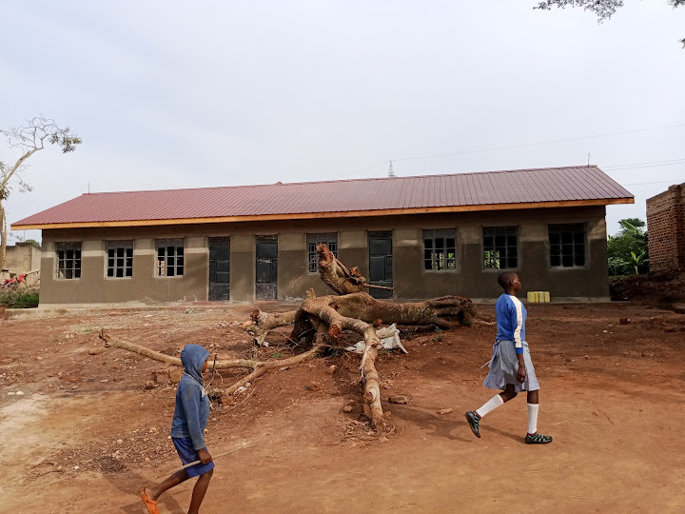
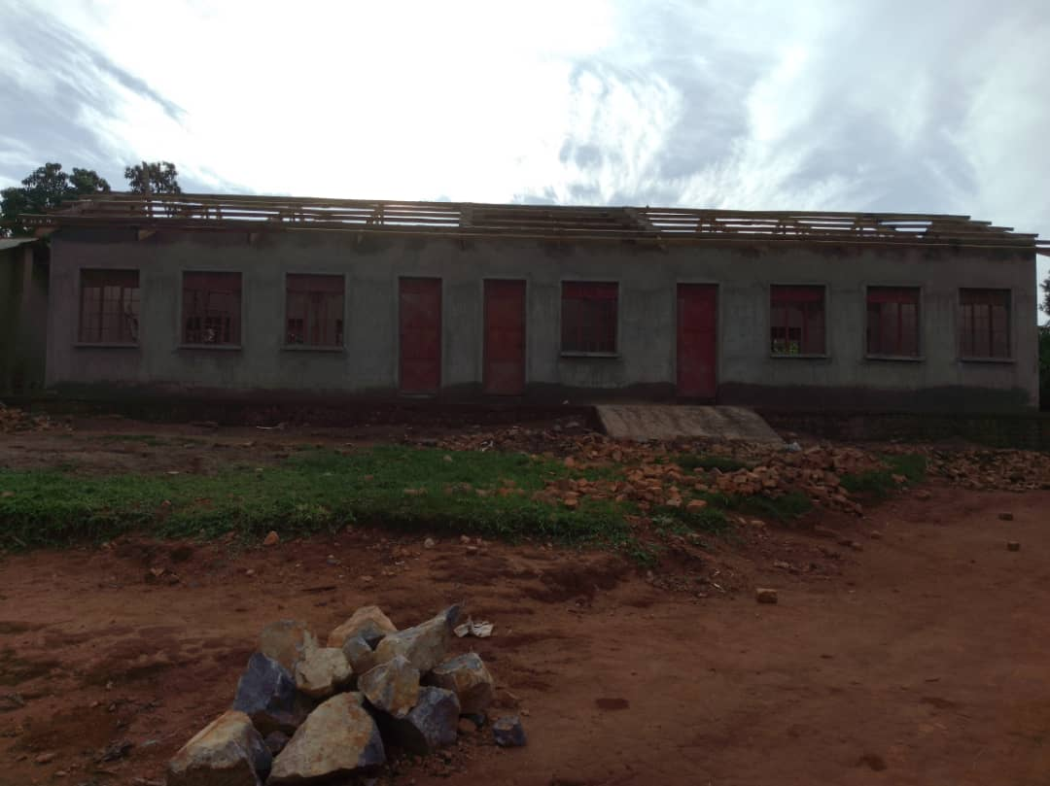
Two classroom block, office and store at Two classroom block, office and store at
Balimanyankya P/S in Lwengo S/C. Kiwangala P/S in Kisekka S/C.
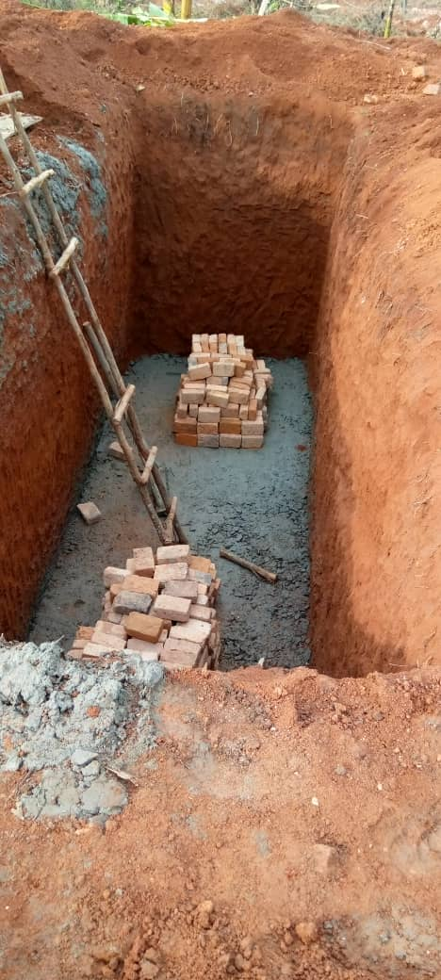
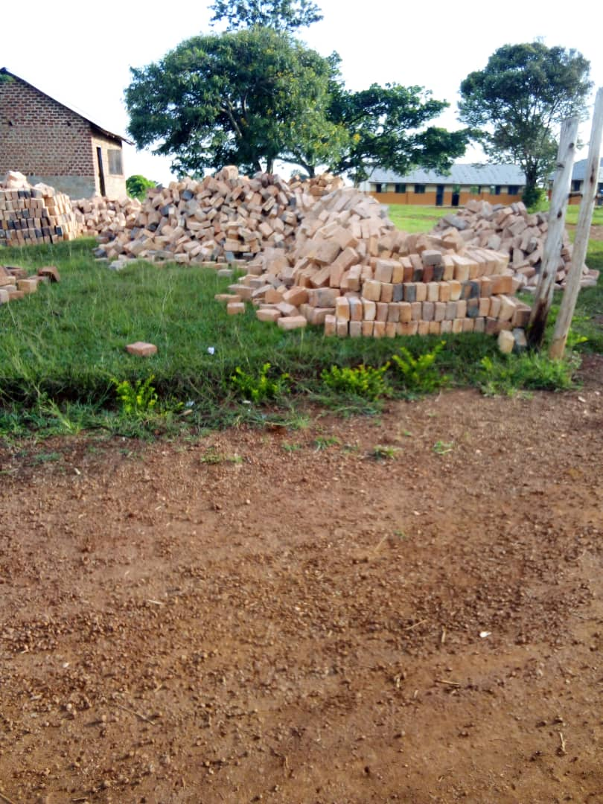

Ongoing construction works of 5 stance lined latrine at Bigando P/S `
HEALTH DEPARTMENT
In FY2024/2025 the Department has achieved the following;
Paid Staff salaries and PHC direct transfers to facilities, Prepared monthly, quarterly & annual HMIS reports, conducted DHT integrated support supervision/political monitoring and MCH support supervision. Held quarterly performance review meetings, monthly DHT meetings and quarterly EDHMT meetings. The department has also conducted malaria prevention, control and management activities, HIV prevention & care activities and voluntary medical male circumcision activities, Coordinated cervical cancer routine screening and also routine screening for non-communicable diseases (hypertension, diabetes). Conducted supply chain management trainings, continuous quality improvement at District and health facility level, VHT and CHEWS training and pass out ceremony, routine immunization activities, family planning activities.

PROJECTS FOR HEALTH DEPARTMENT FOR FY 2024/2025
- Fencing /latrine & water tanks at Kikenene HC II
- 5 stance pit latrine construction at Lwengo HC IV/5 and at Naanwya HC III
- Stone Pitching at Lwengenyi HC III, Construction of placenta pit at Naanywa HC III
- UMEME connection at Kyetume HCII
- Fencing Katovu Kamazi HC III

The Health Sector in the Financial Year 2025/2026 will;
Pay Staff salaries and PHC direct transfers to facilities, Prepare monthly, quarterly & annual HMIS reports, conduct DHT integrated support supervision/political monitoring and MCH support supervision, Hold quarterly performance review meetings, monthly DHT meetings and quarterly EDHMT meetings, Conduct malaria prevention, control and management activities, HIV prevention & care activities and voluntary medical male circumcision activities, Coordinate Yellow fever vaccination, cervical cancer immunization activities and routine screening for non-communicable diseases (hypertension, diabetes), Conduct supply chain management trainings, continuous quality improvement at District and health facility level, VHT trainings, routine immunization activities, family planning activities, and other epidemic response activities, On cross cutting issues, the Department will support Gender and Community Development and Natural Resource Department in male engagement about family issues to reduce on gender based violence issues and screening and monitoring of development projects respectively.

INTERGRATED TRANSPORT PROGRAMME
ROADS AND TECHNICAL WORKS
Mr. Speaker Sir, the Works and Technical Services sector has covered the following roads during FY2024/2025;
PROJECTS UNDER WORKS FOR FY 2024/2025.
- Kinoni – Kyamaganda – Kisekka Road
- Makondo – Micunda – Lwengo Road
- Kayiria-Mijuma-Kibingekito
- Kitooro – Lusaka Road
- Kitooro – Keikolongo Road
- Kitooro – Buyinja – Ndagwe Road

Had Operational costs which include;
- Repaired and serviced of road equipment
- Facilitated Road committee sitting and prepared reports and accountabilities
- Did Routine Labour Based for district roads

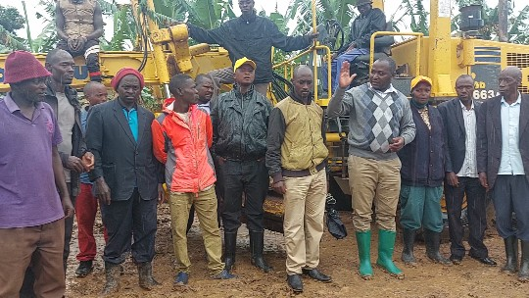
LIST OF ROADS TO BE WORKED ON IN THE FY 2025/2026
Road Name | Length (km)
Kinoni – Nakalembe – Kibulala Road | 3
Katovu – Kyampalakata Road | 8
Ndagwe –Jjaga – Lwengo Road | 15
Kyawagonya – Lwamanyonyi – Jjaga Road | 10
Kakoma – Bakijjulula – Kitwe Kyanjovu Road | 7.3
Kalyemanvu - Kamuwaza - Kikanika | 12
 | 55.3

Other activities to be done during FY 2025/2026
The Department will repair vehicles and Road equipment, prepare bills of quantities and specifications for all contracted projects for FY 2025/2026, pay staff salaries, conduct quarterly road committee meetings, supervise and monitor contracted works for both Higher and Lower Local Government and prepare quarterly accountabilities and Prepare and submit departmental annual budget and quarterly reports to Uganda Road Fund and other line Ministries.

NATURAL RESOURCES, WATER AND CLIMATE CHANGE
WATER
Water Department
This Sector is mandated to provide the people of Lwengo District with clean and safe water through mobilization and sensitization of communities on aspects of water and sanitation, construction and protection of safe water sources in order to increase safe water coverage and improve the level of hygiene and sanitation.
Mr. Speaker Sir, to ensure the attainment of the above mandate, the following are completed achievements for FY2024/2025

PROJECTS UNDER WATER DEPARTMENT FOR FY 2024/2025.

Sn | Sub county | Activity | Location
1. | Ndagwe sub county | 01-30 Cubic Litres | Kachiraga
2. | Lwengo sub county | 01-30 Cubic Litres | Mbirizi Seed School
3. | Kyazanga sub county | 01-30 Cubic Litres | Ngugo Church
4. | Kyazanga sub county | 01-30 Cubic Litres | Lyakibirizi Church
5. | Malongo sub county | 01-30 Cubic Litres | Kigeye Church
6. | Malongo sub county | 01-30 Cubic Litres | Kabusirabo Church
7. | Malongo-Katovu | 01-30 Cubic Litres | Katovu Seed
8. | Malongo-Katovu | 01-30 Cubic Litres | Katovu Community
9. | Malongo-Katovu | 01-30 Cubic Litres | Katovu-Masqid
10. | Kkingo | 01-30 Cubic Litres | Katovu-Masqid
11. | Malongo sub county | 01-Valley tank | Lwentale
12. | Malongo sub county | 01-Minisolar powered | Kalagala
13. | Lwengo District | Borehole spares | District Stores
14. | Lwengo District | 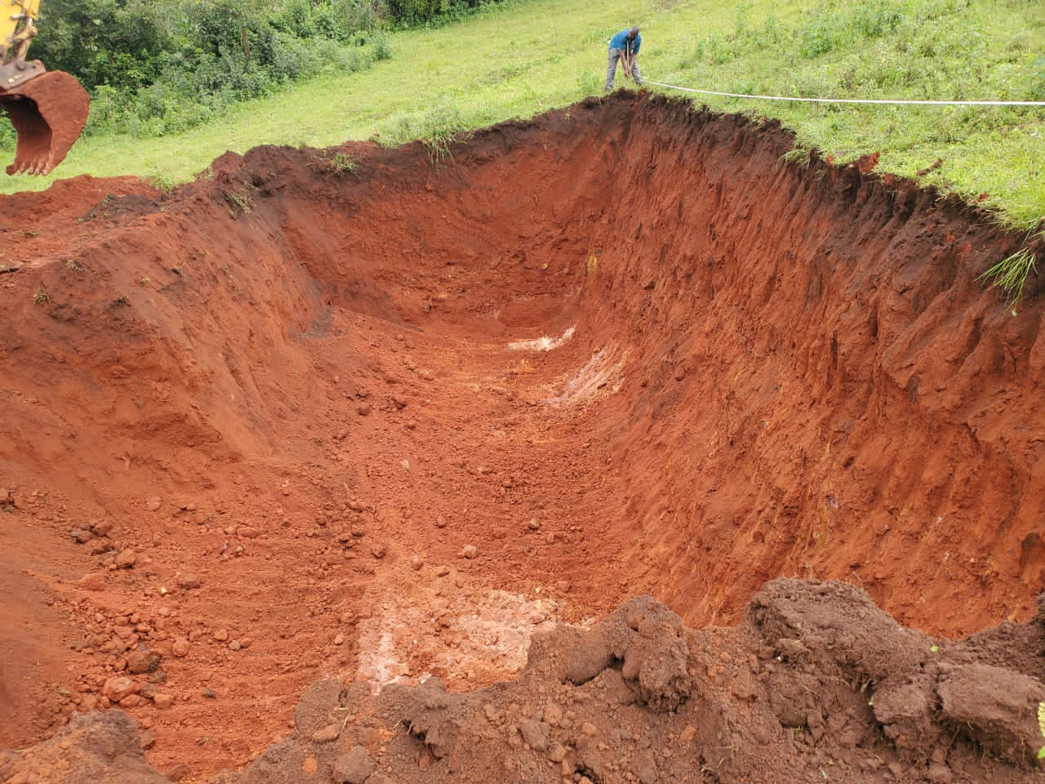  Water testing Kit | District Stores
15. | Lwengo District | Designs | District Stores
16. | Kyazanga | Deep borehole drilling | Kengwe
17. | Kisseka | Deep borehole drilling | Katooke
18. | Ndagwe | 5 stance latrine | Nanywa market

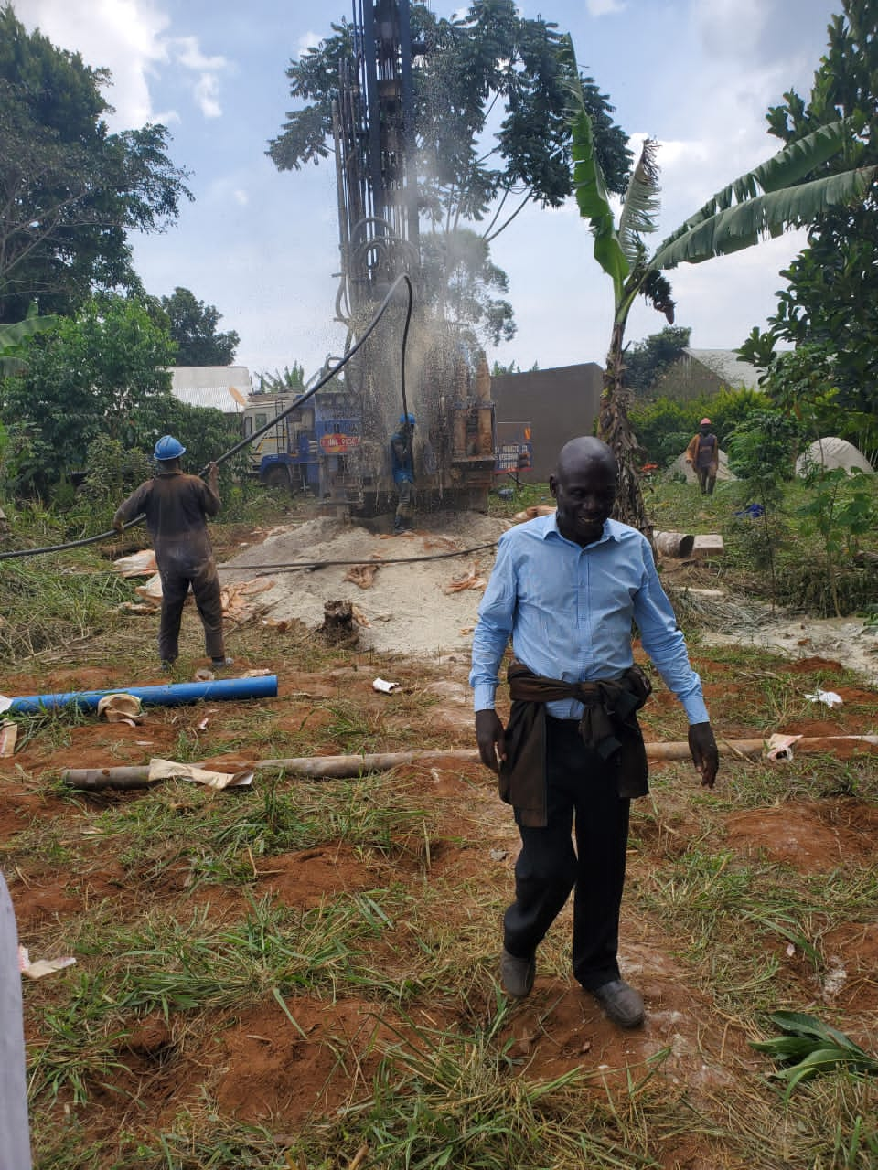

Borehole Drilling at Kyekulura Kissekka S/C Valley Tank works at Nakalago Kyazanga S/C

In the FY2025/2026, The Water Department will implement the following planned activities;
Coordination of stakeholders to receive new facilities and Non-Government Organizations in water service, Repairs and purchases of office equipments for District Water office, General operation costs of District water office, Monitoring and supervision of new and old water sources in the District, Operation and Maintenance of urban water facilities constructed in the previous 3 years, Community mobilization to co-funding, management committees to water sources and trainings.

Planned Capital Development projects for FY 2025/2026.
Sn | Key output | Proposed Amount | Sub county
00. | Transitional Devt (Sanitation& Environment) | 14,814,815 | Kisseka
01. | District rural Water Non-wage recurrent | 80,834,172 | District Headquarter
 | SUB TOTAL | 95,648,987
1. | Construction of public Latrine in RGCs | 26,200,000 | Lwengo
2. | 30M³ Brick masonry tanks (5) | 232,360,968 | Malongo, Lwengo Ndagwe, Katovu, Kkiseka,
3. | Borehole drilling and Rehabilitation. | NIL | NIL
4. | Purchase of borehole spares | 39,604,309 | All sub-counties
5. | Construction of piped water supply systems. | Nil | Nil
6. | Supply and Application of Valley Dams Linner | 40,000,000 | Kyazanga-Nakalago
 | Grand Total | 338,165,277

NATURAL RESOURCES
Under this sector, the following were achieved;
The sector has registered achievements in the areas of climate change response, wetland management and restoration as well as introducing participatory approaches that aim at reversing the trend of loss of bio diversity in the district. Mitigation and adaptation technologies are being mainstreamed in projects and programmes of both State and non State Actors. However, there still exist challenges that continue to threaten the district’s environment and natural resource base
Restoration of fragile ecosystem
Lwengo district has basically two fragile ecosystems, these include wetlands and bare hilltops. Wetlands in the district cover approximately 10% of the total land area. There has been wetlands inspections, monitoring and subsequently issuance of wetland improvement Notices to over 400 encroachers in Lwengo S/C (Mayira, Nkunyu and Kyanjovu Wetland), Kisekka S/C, Kkingo S/C (Kisansala- Ngondati and Nakatooke-Bigando wetlands) and Ndagwe S/C, carried out follow-up activities such as training and awareness creation of communities with substantial encroachment (Bulimbale Dam wetland and Kakukuulu wetland in Malongo S/C), inspections of sub counties environment management initiatives, cautioning of the culprits and giving them some grace period to harvest their produce, Demarcation inspection of a 50km stretch at Kiyanja- Kaku wetland in Kyanzanga T/C and Lwengo sub-county which was done in 2021/2022 amidst challenges of protests by the community. Sensitizations were done but political actors politicized the process. Over 1000 bamboos were uprooted by the communities.
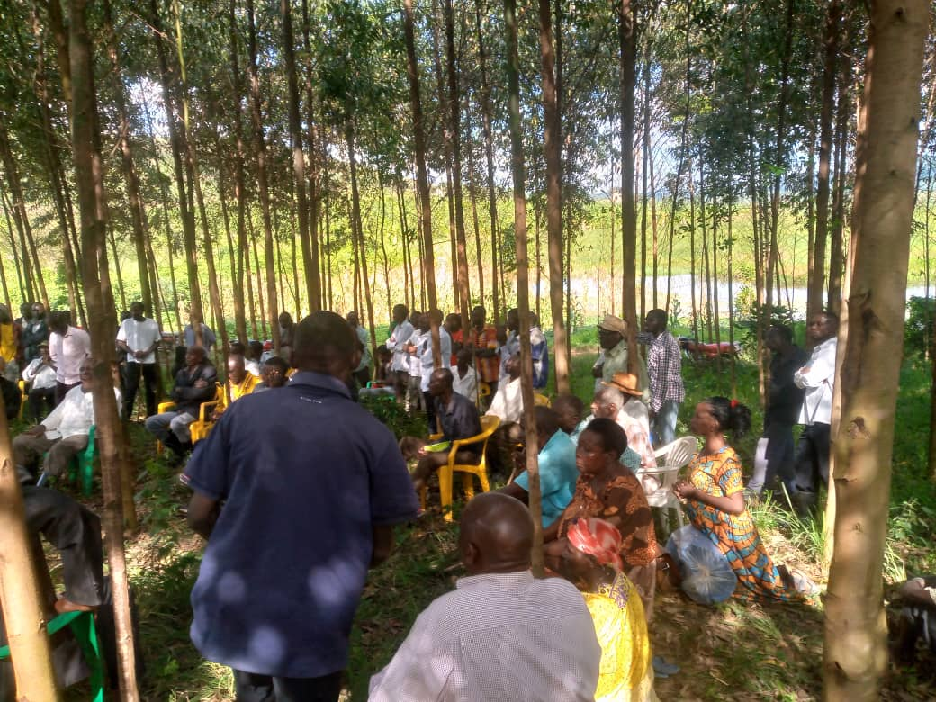
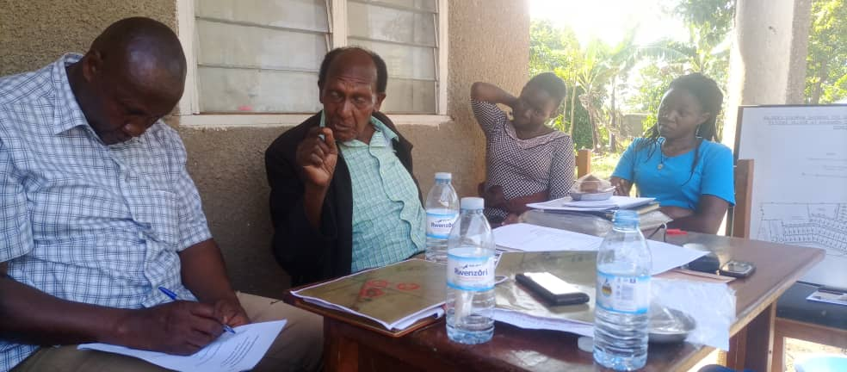
Sensitization at Bulimbale Dam District Land Team discussing MOU with by Environment Management Team Hon. Bazira Ssewanyana who donated land at Kamazzi for construction of HC III
Land management services
Embarked on Mass land registration in Kyazanga T/C, Kyazanga S/C and Malongo S/C. Over 350 titles have been completed and issued to owners, 50 are still in process and about 25 unclaimed.
The district had put aside ten million for payment of Land (Hajji Kitatta). Unfortunately, we are too late. Let us use this money to secure land from the Uganda Land Commission.
We have embarked on registration of land at Katovu TC seed school and Katovu HC IV upgrade at Kamazzi which was donated by Hon Henry Bazira Ssewanyana.

On physical planning, 3 Physical Planning committee meetings have been held, 2 Land Board meetings have been held and over 30 developers have been guided on new development. Participated in all Town Council Physical planning Committee meetings, 34 land inspections done and twelve million shillings was collected under local revenue. 25 dispute resolutions handled and 12 disputes resolved so far. However, the District has no functional Land Board hence affecting Land management processes in the district.
Forestry and tree planting
Activities done were inspection and patrolling for illegal forest activities, revenue collection where about shs 1,500,000 has been collected, advised and trained 68 farmers on tree planting and agro-forestry management. However, having majority of farmers dealing in coffee, agro-forestry has been resisted due to prevalence of the coffee twig borer. Inspected and trained nursery operators in 11 locations and We set up 5 demonstration plots for Clonal Eucalyptus at the district, in Malongo, Kyazanga and Lwengo sub counties and procured a laptop for the department.
Oil and gas
The district is being crossed by the Oil pipeline, in this respect therefore, we have had sensitizations in various fora about the resource and how the mid-stream actors can benefit. So far compensation is about 85% complete, re-settlement action plans are being implemented by constructing houses for PAPs and training of the Youth of PAPs in tailoring, welding and catering at St Charles Lwanga technical institute Butende and Mummy's technical institute at Nyendo Masaka, Titling process of the right of way and issuance of Vacation Notices has also commenced and Training of potential suppliers of goods and services in business management skills is ongoing at Mbirizi Catholic Church.
Partnerships with other Organizations
The district is partnering with ICF, Nature Uganda to cater for wetlands and Crane conservation in the District. We celebrated World Wild life day at Kasambya P/S in Sembabule district where the Tourism section represented the district. Among the activities conducted by the Partnerships include but not limited to; income generating activities in poultry/piggery, training in agronomic practices on wetland banks/wetland edge farming. The department also trained two staff in scientific wetland assessment and sensitized on wetland/crane conservation, monitored crane nests in Birunuma, Kirumba and Kyakabandagala among others.

Land management services
Embarked on Mass land registration in Kyazanga T/C, Kyazanga S/C and Malongo S/C. Over 350 titles have been completed and issued to owners, 50 are still in process and about 25 unclaimed. The district has released ten million for payment of Land (Hajji Kitatta), we have embarked on registration of land at Katovu TC seed school and Katovu HC IV upgrade at Kamazzi which was donated by Hon Henry Bazira Ssewanyana.

Physical planning, 3 Physical Planning committee meetings have been held, 2 Land Board meetings have been held and over 30 developers have been guided on new development. Participated in all Town Council Physical planning Committee meetings, 34 land inspections done and twelve million shillings was collected under local revenue. 25 dispute resolutions handled and 12 disputes resolved so far. However, the District has no functional Land Board hence affecting Land management processes in the district.
Natural Resources
In the FY2023/2024, The Department will implement the activities summarized below;

Titling of land in at least 5 government institutions especially at health centers and education facilities, Demarcation of 100km stretch of wetland in Kkingo, Malongo, Ndagwe, Kisekka and Kyazanga sub counties, Sensitization of 200 local stakeholders in conservation activities, Screening, inspection and certification of atleast 30 projects in next Financial Year for environmental compliance, Participation in oil and gas activities most especially monitoring RAP and construction activities for social and environmental safe guards, Registration of at least 50 parcels of land in the District for private persons.

COMMUNITY MOBILISATION AND MINDSET CHANGE
GENDER AND COMMUNITY BASED SERVICES
The Sector achieved the following;
Supported the implementation of YLP program. Total amount so far received since the start of the program in 2014, is shs 1,001,733,950 in 134 groups with 1,506 (816 male and 690 female) beneficiaries; and shs 217,383,500 has been recovered, Supported the implementation of UWEP program. Total amount of UWEF so far received since 2016/17 is shs 656,418,069 in 95 women groups with 1,009 beneficiaries. Shs. 189,298,200 has so far been recovered, Supported the implementation of PCA Model in 26 parishes with 5,798 males and 3,796 females in 503 Community Groups. Have so far received shs. 810,000,000 under the programme as detailed below; Number of PCAs supported: 10 PCAs in 2018/2019,05 PCAs in 2019/2020, 06 PCAs in 2020/2021, 06 PCAs in 2021/2022,Received and handled sixteen social conflicts under the probation office; one was, referred to Court, two to FIDA and the rest were reconciled, 14 cases were received by Lwengo legal aid clinic coordinated by FIDA Uganda and 100% of them have been concluded through mediation and counselling, 9 cases of GBV were received by OKOA Refuge center in Mbiriizi, 4 Juvenile offenders were represented in courts of law and social inquiries made on each, Conducted quarterly review meetings for all social protection committees with support from MADDO who are working with OVC, 3 GBV follow-up visits to resolve family conflicts conducted, 12 Department staffs monthly salaries validated and paid, Key planning activities especially under PDM enhanced, monitored and support supervised, 4 missing children resettled with their families by the district probation office, 10 sector staff supported to implement, monitor and support supervise PDM activities at Parish level, Supported the Youth Council, Women, Disability, and Old persons' Councils to conduct District Executive meetings, Supported the commemoration of the international day for older persons, Mobilized for the payment of Older persons under the SAGE program, 020/2021, 06 PCAs in 2021/2022,
Received and handled sixteen social conflicts under the probation office; one was referred to Court, two to FIDA and the rest were reconciled, 14 cases were received by Lwengo legal aid clinic coordinated by FIDA Uganda and 100% of them have been concluded through mediation and counselling, 9 cases of GBV were received by OKOA Refuge center in Mbiriizi, 4 Juvenile offenders were represented in courts of law and social inquiries made on each, Conducted quarterly review meetings for all social protection committees with support from MADDO who are working with OVC, 3 GBV follow-up visits to resolve family conflicts conducted, 12 Department staffs monthly salaries validated and paid.

In the FY 2023/2024 the Department will accomplished the activities below;
Respond to Gender mainstreaming through Support to GBV activities and Gender audit in development programs, Provide inspection, monitoring and Labour Management services by supporting labour based institutions' support supervision and monitoring, arbitration and follow up of completed labour conflicts, Promotion of Arts and Crafts by supporting community sports and local creative Artists and positive cultural advancement, Respond to HIV/AIDS mainstreaming by conducting sensitizations on HIV/AIDS prevention and fighting stigma within communities, Promotion of proper implementation of PDM and all other government programs by supporting monitoring and support supervision of sector programs, projects and activities, Provide Capacity Development services through support to retreats and study Tours for both political and technical staff, Support to special interest groups by supporting Women, Youth, Disability and Old persons Councils' activities and provide social rehabilitation services to PWDs, To provide Community mobilization and empowerment Services by facilitating Community Development Workers to implement sector programs, projects and activities and provide support to Parish Community Associations (PCA) under Luwero/Rwenzori Project. And also shall support community mobilization for participation in integrated community learning and wealth creation program (ICOLEW), Promote Social protection and empowerment by supporting the provision of Probation and social welfare services.

TRADE, INDUSTRY AND LOCAL ECONOMIC DEVELOPMENT DEPARTMENT PERFORMANCE SNAPSHOT FOR FY 2024/2025

Below is the Summarized Performance Highlights under the Outputs of Cooperatives Promotion and Outreach, Trade Development Promotion Services, Tourism Development Promotion Services and Industry development Promotion Services.

COOPERATIVES PROMOTION AND OUTREACH
- Registered 4 Cooperative Societies that is, Mpaama Kwegatta community, Mujo Mbiriizi microfinance, Kamuwaza Tulibumu community Development and Degaya Kasensudu Tulibamu Saving and credit cooperative Societies Ltd.
- Monitored the performance of the 54 Emyooga SACCOs in Lwengo District that had received a total grant of Ushs.2.46 Billion which includes seed capital of Ushs. 1.68 Billion and Extra Funding of Ush. 800 Million. Cumulatively, Ushs. 4,753,492,500 has been disbursed to 2,665 beneficiaries of whom 41% Female and 59% Male
- Backstopping of 45 PDM SACCO leaders in record keeping, WENDI mobile wallet and governance issues
- 16 ordinary SACCOs were Monitored and Backstopped in Loan Portfolio Management.
- 12 Farmers Cooperative Societies were Monitored and Backstopped in Governance, Record Keeping and Group Dynamics.
- Attended 2024 AGMs for Kyazanga Kweggatta Micro Finance SACCO, Lwengo microfinance SACCO, Kinene Coffer cooperative society, Kyazanga HUDA community multipurpose cooperative society, Kyazanga Twezimbe Multi-purpose cooperative society Malongo Tugaggawale SACCO, Kinoni Traders and Farmers SACCO and Kiwangala Tulibumu Development SACCO
- Facilitated the renewal of the Probation Registration certificate for Kisekka Trinity SACCO.
- We have also submitted 11 Emyooga SACCOs to Microfinance Support Centre for increment of their Seed Capital by 20 Million each.

- TRADE DEVELOPMENT
- 658 Business evaluated and assessed for issuance of trading licenses in the Kyazanga Town council and Kinoni Town council
- 47 businesses/enterprises inspected in the District towards compliance with the existing laws including existence of the counterfeit, uncertified and expired products on the market
- Inspection and supervising of businesses in 4 town councils especially on locally produced (beverages) and counterfeit products was conducted.
- 2 Trade inspections for Compliance with Existing Laws was done in the 3 Constituencies of Bukoto South, Bukoto West and Bukoto Midwest.

- TOURISM DEVELOPMENT
- Inspection and backstopping of the hospitality facilities operators conducted to check on Compliance with the existing Laws, Uganda Tourism Board (UTB) guidelines and Health SOPs.
- Sensitization of hospitality operators in Kinoni and Katovu Town Councils on Financial Literacy including Record Keeping conducted
- INDUSTRIAL DEVELOPMENT
- Inspection of Value Addition Facilities in Lower Local Governments to assess their compliance with existing Laws and guidelines.
- Backstopping of value addition facilities owners in record keeping and its purpose and benefit
- SECTOR MANAGEMENT AND MONITORING

- Monthly sector reports, including the Emyooga program, 2025/26 sector budget estimates were prepared and shared with the stakeholders
- Ensuring payment of Staff Salaries in time.
- CHALLENGES
- Low Compliance to existing Laws and regulations by all categories of Business Enterprises.
- Inadequate Funding to the sector to carry out its mandate.
- Poor Mindset about some Government Programs by the Community.
- Low Financial Literacy leading to Poor record keeping, Financial Indiscipline and Poor Loan Repayments among Community Members.

- WAY FORWARD
- Continuous Community Sensitization
- Joint Monitoring of Government Programs
- Improved information sharing among all stakeholders

MAIN CONSTRAINTS TO SERVICE DELIVERY
Lack of transport for revenue mobilization, supervision and monitoring of recurrent and development activities both at District and sub county level, Lack of institutions like babies’ remand homes and rehabilitation centers in the district, High financing costs on management of Juvenile offenders from police and court to the remand home in Kampala, Many Elderly persons are so weak and fragile that fail to reach the pay point. The few who reach the pay points are usually disgusted with the slow and clumsy processes involved, Low adaptability to compliance due to mindset issues, Governance Challenges in some Cooperatives esp. Emyooga, enforcement of regulations among the key players like office of RCS, SMEs with uncertified products are on increase, Animal theft is very high in the community especially in Sub Counties. Failure by most District Stakeholders to appreciate and participate fully in planning issues, Late submission of quarterly mandatory documents like Reports and Work plans thereby delaying the consolidation of the district documents hence late submission to line MDAs, Insufficient funds to adequately carry out Planning, Budgeting, Monitoring and Evaluation activities in the District.
In Conclusion
Finally, this would not happen if Lwengo District was not peaceful. I salute the District Security team led by the Resident District Commissioner and the vigilance of the population of Lwengo for the peace that is prevailing in every corner of the district. Everything else depends on this.
Mr. Speaker Sir, allow me through you to extend my appreciation to our development partners who have contributed to the development of Lwengo District in the Financial Year 2024/2025 and our bankers Finance Trust Bank who have been with us in all our endeavors, We request for continued support in F/Y 2025/2026.

I request the engagement of all stakeholders of the District to ensure collective responsibility towards the development of Lwengo District.

Mr. Speaker Sir, allow me also to extend my appreciation to the Chief Administrative Officer, Chief Finance Officer, the District Technical Planning Committee, the Budget Desk and all members of staff who have worked tirelessly for 2024/2025 Financial Year achievements.
I commend the District Executive Committee and Standing Committees for their contribution towards the NRM Government’s Development agenda.
I look forward to working together in the attainment of the District goals and objectives for the betterment of Lwengo District and Uganda as a country.

A big thank you to our clients, political leaders and our dedicated team of Lwengo District Local Government.

For God and My Country

